20160923
# How to see web page with more eye friendly view.

# Without curl - receive web-page.
[belogrud@dockergate 20190123-2021]$ w3m http://localhost:8080 -dump -T text/html
You've hit 0589ea505a4a
[belogrud@dockergate 20190123-2021]$

# Or receive web page with only curl.
[belogrud@dockergate 20190123-2021]$ curl http://localhost:8080
You've hit 0589ea505a4a
[belogrud@dockergate 20190123-2021]$

# With curl and proxy receive web page.
root@ds-clickhouse01t:~# curl -x http://repo-linux:80 http://linux.dell.com/repo-linux-redirect-via-proxy/repo/community/ubuntu/dists/trusty/ | w3m -dump -T text/html
% Total % Received % Xferd Average Speed Time Time Time Current
Dload Upload Total Spent Left Speed
100 2461 100 2461 0 0 4296 0 --:--:-- --:--:-- --:--:-- 4302
Index of /repo/community/ubuntu/dists/trusty

[ICO] Name Last modified Size Description
━━━━━━━━━━━━━━━━━━━━━━━━━━━━━━━━━━━━━━━━━━━━━━━━━━━━━━━━━━━
[DIR] Parent Directory -
[ ] Contents-amd64 16-Jun-2016 11:57 2.5M
[ ] Contents-amd64.bz2 16-Jun-2016 11:57 149K
[ ] Contents-amd64.gz 16-Jun-2016 11:57 277K
[ ] Contents-i386 16-Jun-2016 11:57 3.8K
[ ] Contents-i386.bz2 16-Jun-2016 11:57 628
[ ] Contents-i386.gz 16-Jun-2016 11:57 539
[ ] Release 16-Jun-2016 11:57 29K
[ ] Release.gpg 16-Jun-2016 12:00 836
[DIR] openmanage/ 16-Jun-2016 11:56 -
━━━━━━━━━━━━━━━━━━━━━━━━━━━━━━━━━━━━━━━━━━━━━━━━━━━━━━━━━━━

root@ds-clickhouse01t:~#

20170118
# From where installed w3m utility.
[root@ds-gw-git01 ~]# yum install w3m
...
Dependencies Resolved

=====================================================================================================================================================================================================
Package Arch Version Repository Size
=====================================================================================================================================================================================================
Installing:
w3m x86_64 0.5.2-19.el6 tcs-rhel-x86_64-server-6 889 k
Installing for dependencies:
gc x86_64 7.1-12.el6_4 tcs-rhel-x86_64-server-6 146 k

Transaction Summary
=====================================================================================================================================================================================================
Install 2 Package(s)
...

http://askubuntu.com/questions/58416/how-can-i-preview-html-documents-from-the-command-line

How can I preview HTML documents from the command line?
up vote10down votefavorite  5 | I use catdoc to preview Word documents from the command line. Is there something similar for HTML?  In other words I would like to do cathtml Webpage.html | less and get more or less a man page look output.  command-line html  shareimprove this question edited Jun 6 '12 at 22:49  fossfreedom♦ 127k30295332 asked Aug 23 '11 at 20:09  isomorphismes 6272924
 | add a comment

4 Answers
activeoldestvotes
up vote7down voteaccepted | You can use html2text to look into an HTML document from command line.  sudo apt-get install html2text html2text Webpage.html | less  but not exactly a look similar to man pages, it depends on the html input, of course.  shareimprove this answer answered Aug 23 '11 at 20:16  enzotib 44.1k491125
 | add a comment

up vote6down vote | You could use w3m which should already installed - if however it isn't  sudo apt-get install w3m  An example command syntax:  w3m -dump askubuntu.com | less  It can be used with both URL's as well as file-based html files  w3m -dump index.html | less  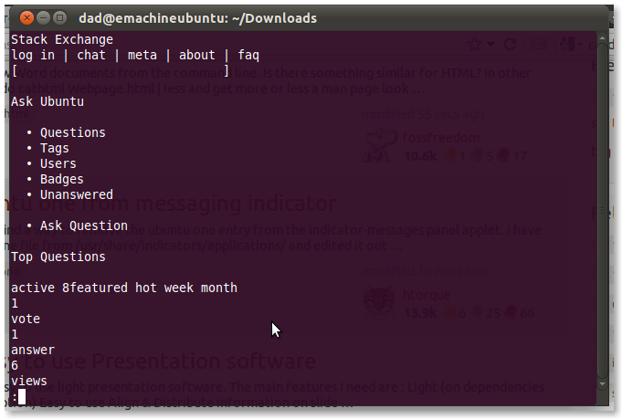  shareimprove this answer edited Aug 23 '11 at 20:29 answered Aug 23 '11 at 20:21  fossfreedom♦ 127k30295332
 | add a comment

up vote6down vote | There are these so-called text html browsers, of which I have successfully tested Lynks and eLinks. Of which elinks has became my favorite.  Anyway, they are different than a "web page previewers" as you suggest in your question. They are more like active real time browsers, which carries on lots of useful features for an easy web browsing and of course, you can also use it for local/remote web pages preview.  Information about Lynks is in the wikipedia and can be reached clicking here. The information related to the elinks is here.  My elinks screenshot for you to see elinks in action:  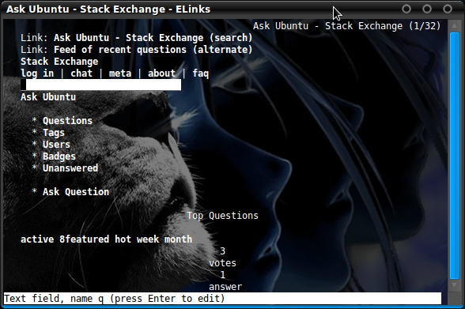  shareimprove this answer answered Aug 23 '11 at 20:51  Geppettvs D'Constanzo 13.6k22155
Nice! Looks very good indeed. – Luis Alvarado♦ Aug 24 '11 at 4:02
Ah - so obvious! After I wrote this question I used w3m, that solved it. – isomorphismes Sep 2 '11 at 5:46
add a comment

up vote5down vote | One solution is to use lynx -dump, as in  lynx -dump file.html  or  echo "<div>this is a div</div>" | lynx -dump -stdin  Better:  Use w3m -dump, it respects the page layout. It is awesome.  sudo aptitude install w3m w3m -dump file.html echo "<div>x</div>" | w3m -dump -T text/html  You can set the number of columns of the terminal for getting the better layout, for example, if you are using a full-window terminal, 200 can be a good try:  w3m -dump -cols 200 file.html

